Analysis, Full Stack Web Development, and Generative AI Solutions
Developed During Internship at Cache Digitech
Moksh Sharma (E23CSEU0381) 6th sem
B.Tech Computer Science, Bennett University, Greater Noida, India

Current Role: Data Analyst Intern, Cache Digitech Pvt. Ltd.
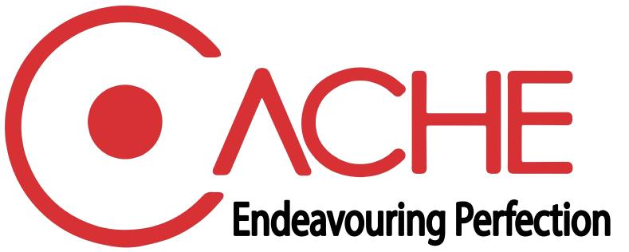

Abstract
This report presents the work carried out during my internship at Cache Digitech, where I contributed across analysis, full stack web development, and generative AI. The internship involved understanding business requirements, interpreting raw technical and operational inputs, and converting them into clear, structured, and scalable solution flows. My work included contributions to projects such as TechBank.ai, CacheBI, Email Intelligence, and website development initiatives. These assignments focused on recruitment workflow automation, business intelligence structuring, email data processing, content organization, and platform-oriented web development. In addition to technical implementation support, I worked on improving documentation quality, feature clarity, process readability, and business alignment for internal and presentation-ready deliverables. The experience strengthened my skills in problem analysis, structured thinking, digital solution design, and practical software development in an industry setting.
Keywords: Generative AI, Full Stack Web Development, Data Analysis, Business Intelligence, Resume Screening, Email Automation

Introduction
The internship at Cache Digitech provided exposure to practical business and technical problem-solving in a live industry environment. My role extended across three connected areas: analysis, full stack web development, and generative AI. This required understanding service lines, identifying the main purpose of technical and business inputs, structuring workflows, and supporting the development of digital solutions that were clear, usable, and aligned with business needs.

Internship Scope
The work was not limited to coding alone. A major part of the internship involved interpreting raw notes, feature descriptions, project summaries, and operational requirements, then transforming them into structured outputs such as solution summaries, page content, task descriptions, and project-ready documentation. This improved both the technical flow and communication quality of the final deliverables.

Methodology and Work Approach
The internship work followed a structured approach. First, project inputs were reviewed to identify the problem statement, workflow, and expected output. Second, the information was reorganized into clear modules such as user journeys, feature blocks, dashboards, content sections, and backend-driven processes. Third, suitable technologies and implementation directions were mapped based on the project type. For web and platform-oriented tasks, the focus was on scalable structure, logical page flow, and user-facing clarity. For AI-oriented tasks, emphasis was placed on prompt-driven processing, structured extraction, classification, and automation. For analytics-oriented tasks, raw business data and fragmented inputs were converted into decision-friendly formats that supported interpretation and presentation.

Primary Areas of Contribution

Area | Nature of Work | Typical Output
Analysis | Understanding raw business and technical inputs, identifying workflow logic, and improving clarity and sequencing. | Structured notes, summaries, requirement flow
Full Stack Web Development | Supporting solution structure, page planning, feature blocks, and business-oriented web implementation thinking. | Page content, modules, interface logic
Generative AI | Assisting AI-driven extraction, matching, classification, and automation-oriented solution design. | AI workflows, prompt-based outputs, smart processing

Project Contributions

TechBank.ai
Objective: To support an AI-powered talent screening and recruitment platform that can organize candidate records, process job descriptions, and improve candidate-matching workflows.
Contribution: I worked on understanding the business flow of recruitment and structuring the project into clear functional components. This included organizing feature logic around resume handling, candidate records, matching flow, and analytics-oriented output.
Project Value: The platform brings recruitment activities into a more structured workflow by reducing manual effort in screening and helping teams move faster from job requirement to ranked candidate insights.
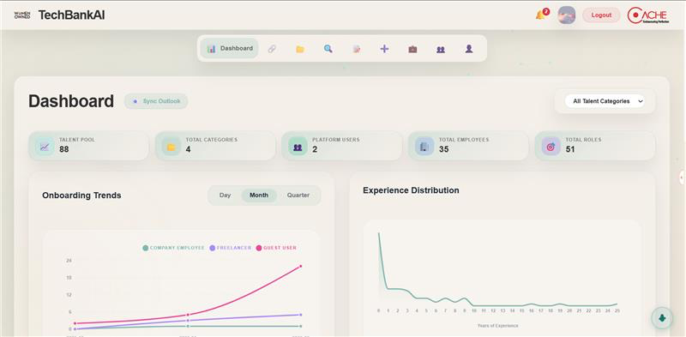

CacheBI
Objective: To convert business and operational information into structured, dashboard-oriented intelligence that can support internal understanding and business presentation needs.
Contribution: I contributed by organizing fragmented information into meaningful categories, helping define presentation-friendly output structures, and improving the readability and sequence of analytics-focused content. Creating Power BI dashboards to developing a BI platform CacheBI for converting raw data into dashboards for analysis.
Project Value: This work supports better data interpretation and helps transform raw information into a format that is easier for stakeholders to understand and use. Helps in creating dashboards with GenAI.
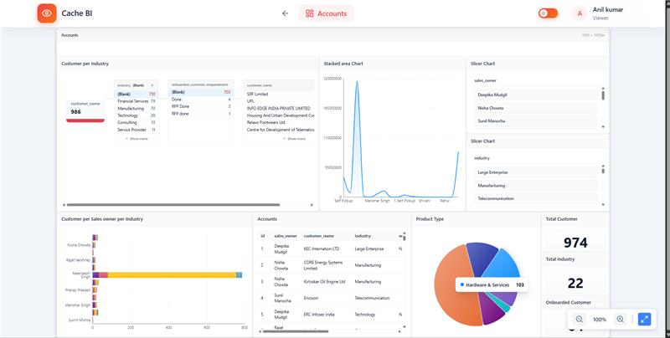

Email Intelligence
Objective: To support a system that can read, structure, classify, and process email data for practical business use cases such as summaries, escalations, lead identification, and administrative visibility.
Contribution: I analyzed the overall workflow of email ingestion and intelligent processing using GenAI and helped structure the communication flow into clear stages including intake, classification, and downstream action-oriented outputs.
Project Value: The project highlights how AI and backend workflows can be combined to automate communication-heavy processes and make large volumes of email information more useful.

Website Development
Objective: To support business-oriented website development through clear content flow, structured page planning, and service-aligned presentation logic.
Contribution: I worked on refining raw content into website-ready structure, organizing service information into logical sections, and supporting page-level clarity for digital presentation.
Project Value: This work improves website usability, strengthens communication of service offerings, and ensures that content is better aligned with user understanding and business positioning.
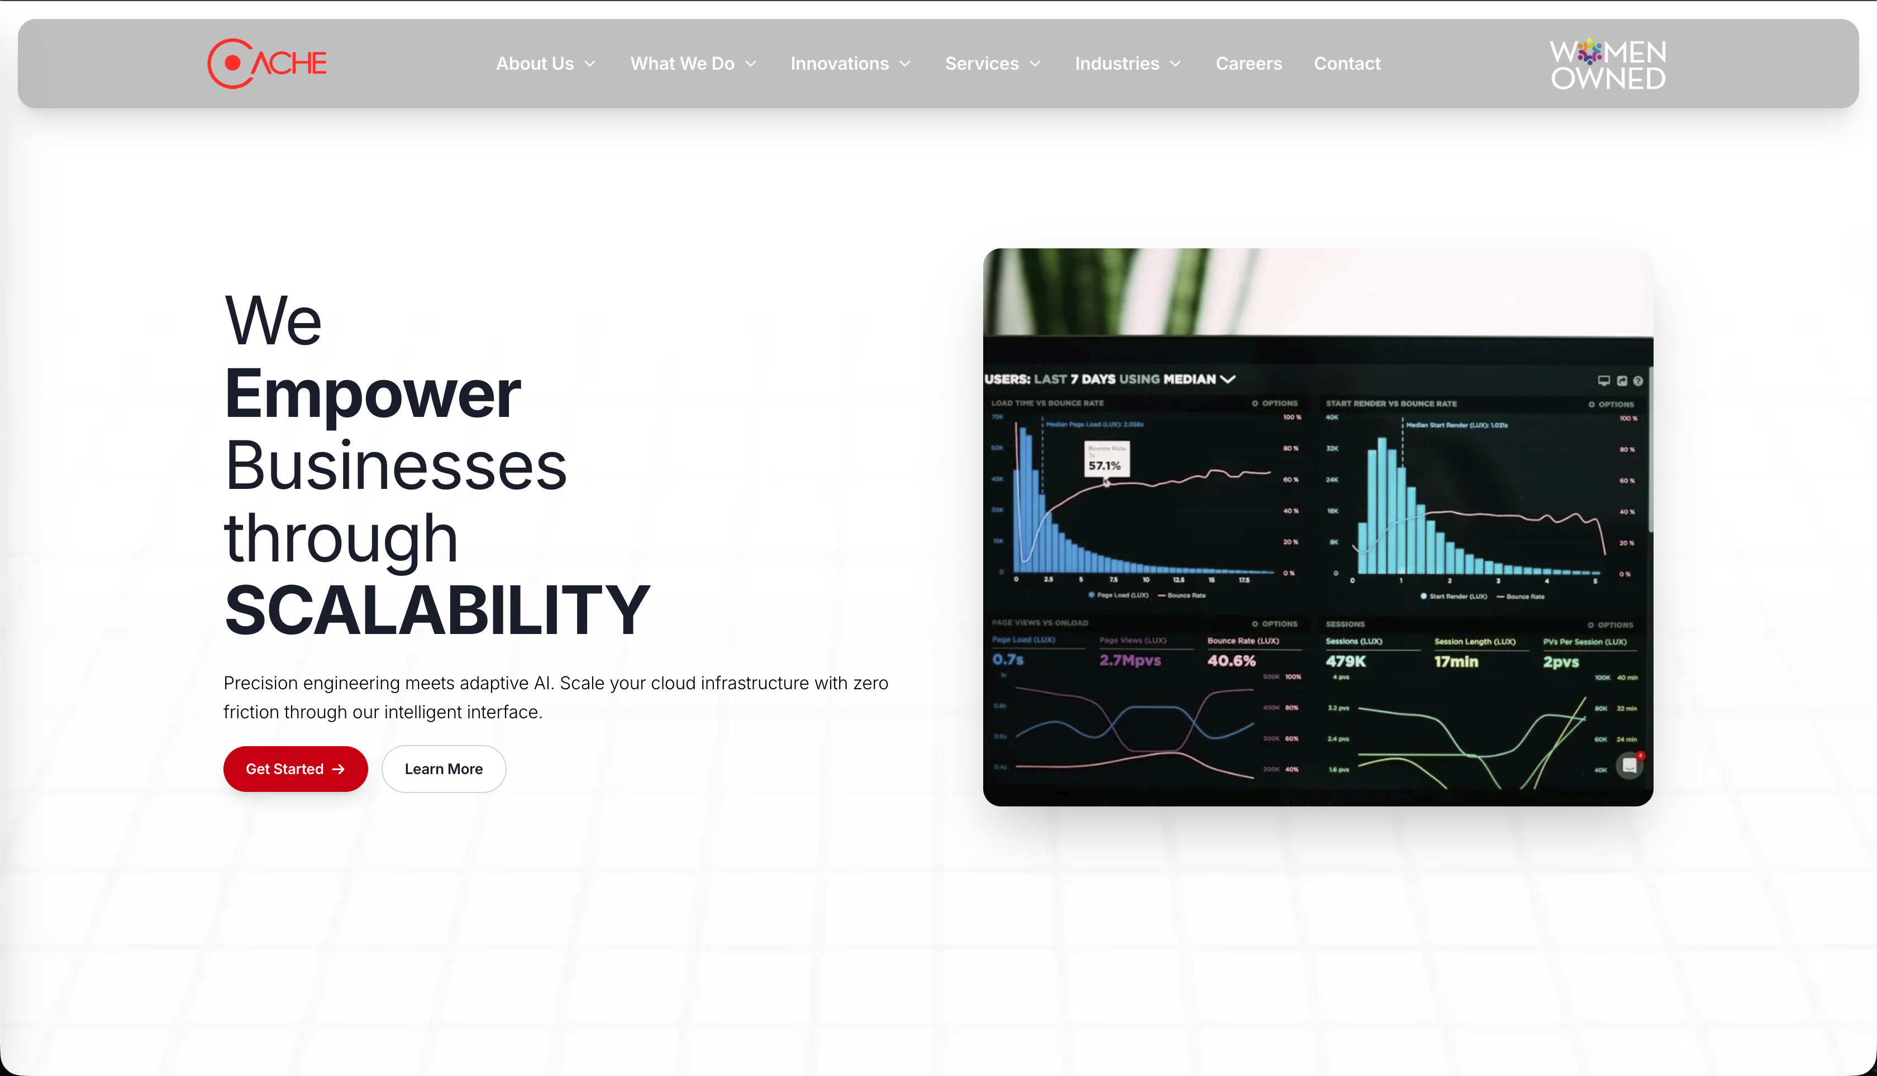

Results and Learning
Across these projects, the common outcome was stronger alignment between business objectives and technical execution. The work improved my ability to understand requirements quickly, organize unstructured information, translate concepts into usable digital flows, and communicate technical ideas in a business-friendly manner. The internship also strengthened my understanding of how AI-assisted workflows, web systems, and analytics thinking can work together in real organizational contexts. My internship at Cache Digitech helped me build practical capability across analysis, full stack web development, and generative AI. Through contributions to TechBank.ai, CacheBI, Email Intelligence, and website development, me and my team gained hands-on experience in converting raw requirements into structured, scalable, and presentation-ready solutions. The experience strengthened both my technical foundation and my problem-solving approach for business-oriented digital systems.

Acknowledgements
I would like to thank the team at Cache Digitech for providing me with the opportunity to contribute to real projects and learn in a practical professional environment. I am also grateful to my mentors and colleagues for their guidance, feedback, and support throughout the internship.

